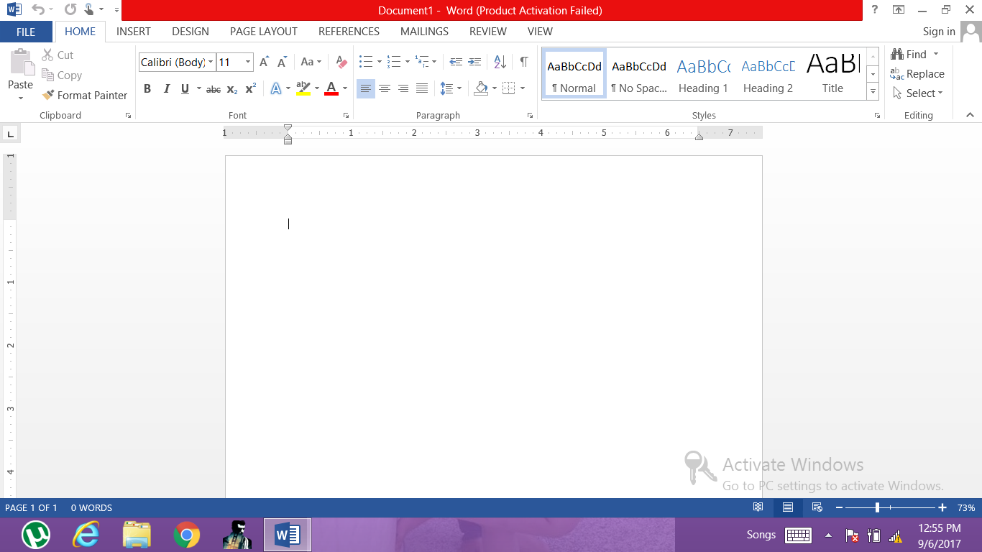

Status bar

Rulers Zoom slide

Word typing space

**Fig.:- Labelled MS Word screen print**